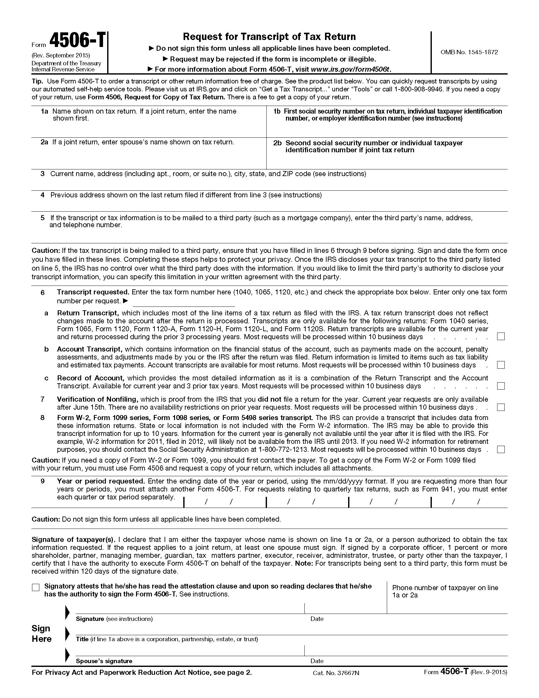

Order No. 01-29018 - 002
Batman
xxx-xx-5555
Axiom Requisition Copy Service, 2869 Jolly Road, Okemos, Michigan 48864
(877) 886-5090 / (517) 886-4116 Fax

1040

